The Litany of Chrysostom (with harmony)
In peace let us pray to the Lord.
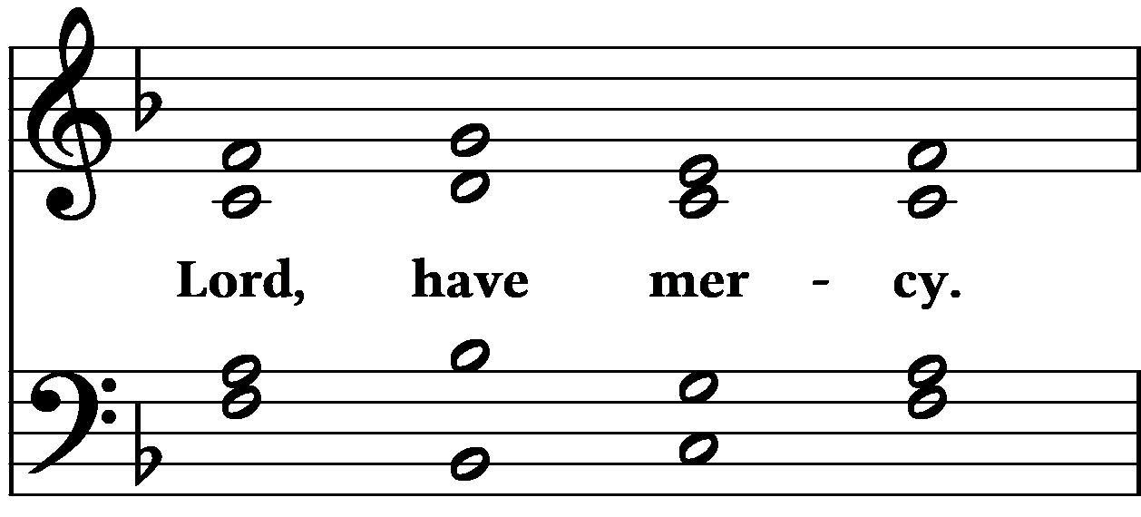
For the peace from above and for the salvation of our souls, let us pray to the Lord.
For peace of the whole world, for the well-being of the holy Churches of God, and for the unity of all, let us pray to the Lord.
For this holy house and for those who enter it with faith, reverence, and the fear of God, let us pray to the Lord.
For our pastors, teachers, and all who are in the service of Christ, and all the clergy and laity, let us pray to the Lord.
For our country, the president, all those in public service, and all our armed forces, let us pray to the Lord.
For this parish and city, for every city and country, and for the faithful who live in them, let us pray to the Lord.
For favorable weather, for an abundance of the fruits of the earth, and for peaceful times, let us pray to the Lord.
For those who travel by land, sea and air, for the sick, the suffering, the captives and for their salvation, let us pray to the Lord.
For our deliverance from all affliction, wrath, danger, and distress, let us pray to the Lord.
Help us, save us, have mercy on us and protect us, O God, by your grace.
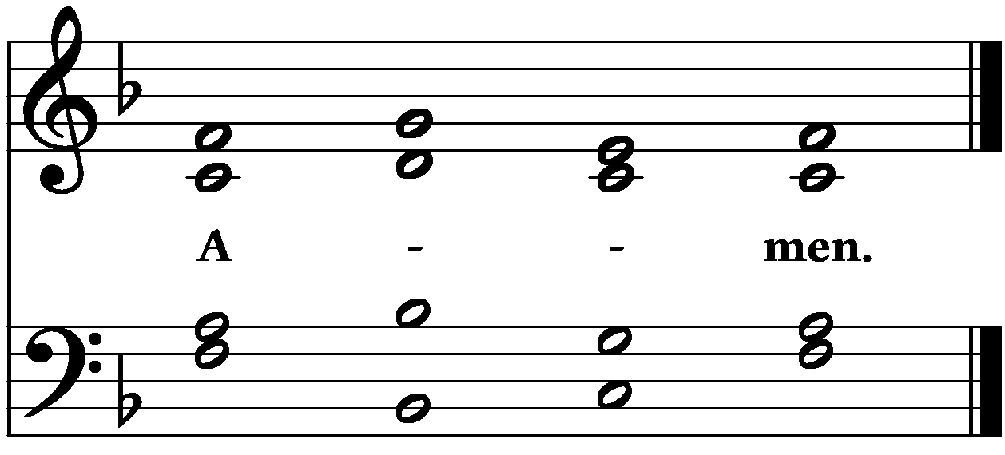

The Litany of Chrysostom (without harmony)
In peace let us pray to the Lord.
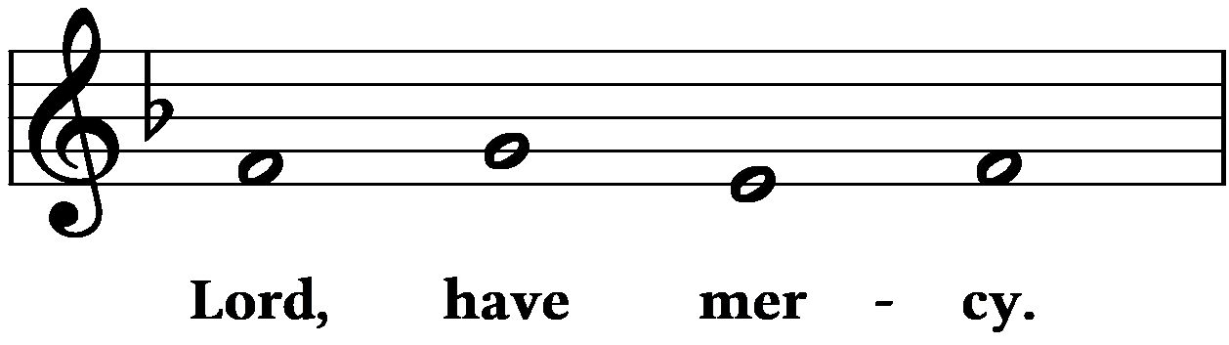
For the peace from above and for the salvation of our souls, let us pray to the Lord.
For peace of the whole world, for the well-being of the holy Churches of God, and for the unity of all, let us pray to the Lord.
For this holy house and for those who enter it with faith, reverence, and the fear of God, let us pray to the Lord.
For our pastors, teachers, and all who are in the service of Christ, and all the clergy and laity, let us pray to the Lord.
For our country, the president, all those in public service, and all our armed forces, let us pray to the Lord.
For this parish and city, for every city and country, and for the faithful who live in them, let us pray to the Lord.
For favorable weather, for an abundance of the fruits of the earth, and for peaceful times, let us pray to the Lord.
For those who travel by land, sea and air, for the sick, the suffering, the captives and for their salvation, let us pray to the Lord.
For our deliverance from all affliction, wrath, danger, and distress, let us pray to the Lord.
Help us, save us, have mercy on us and protect us, O God, by your grace.
